H.T No
Regulations:
A22

Sreenidhi Institute of Science and Technology
(An Autonomous Institution)
Code No:9AC42 Date: 11-July-2025 (FN)

B.Tech I-Year II- Semester External Examination, July-2025 (Regular and Supplementary)
ELECTRICAL CIRCUITS & NETWORK ANALYSIS (ECE and ECM)

Time: 3 Hours Max.Marks:60

Note: a) No additional answer sheets will be provided.
b) All sub-parts of a question must be answered at one place only, otherwise it will not be valued.
c) Missing data can be assumed suitably.
Bloom's Cognitive Levels of Learning (BCLL)

Remember | L1 | Apply | L3 | Evaluate | L5
Understand | L2 | Analyze | L4 | Create | L6

Part - A Max.Marks: 6x2=12

Answer all QUESTIONS, EACH QUESTION CARRIES 2 MARKS.

 |  | BCLL | CO(s) | Marks
1 | Differentiate between Linear and Nonlinear Networks | L4 | CO1 | [2M]
2 | Define bandwidth and Q-factor? | L1 | CO2 | [2M]
3 | State faraday’s laws. | L6 | CO3 | [2M]
4 | State Maximum Power Transfer Theorem? | L1 | CO4 | [2M]
5 | Define port and two port network? | L1 | CO5 | [2M]
6 | An RC circuit has R = 20 Ω and C = 400 µF. Calculate its time constant? | L3 | CO6 | [2M]

Part – B Max.Marks: 6x8=48
ANSWER ALL QUESTIONS. EACH QUESTION CARRIES 8 MARKS.

 |  | BCLL | CO(s) | Marks
7 | Find the equivalent resistance between A and B for the circuit shown in fig. below  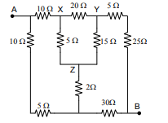 | L3 | CO1 | [8M]
 | OR
8 | Determine current flowing through 2 ohm resistance using nodal analysis method.  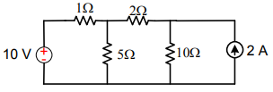 | L5 | CO1 | [8M]
9 | For the waveform shown find the Form factor?  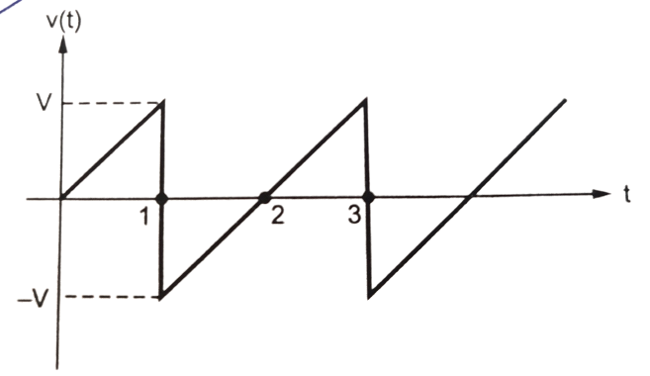 | L1 | CO2 | [8M]
 | OR
10 | Obtain the expression for resonant frequency and Bandwidth for Series R-L-C circuit. | L4 | CO2 | [8M]
11 | Derive the expression of equivalent inductance of two series connected coupled coils? | L5 | CO3 | [8M]
 | OR
12 | Explain about dot convention in mutually coupled circuits. | L2 | CO3 | [8M]
13 | Find the Thevenin’s equivalent circuit for the following circuit.  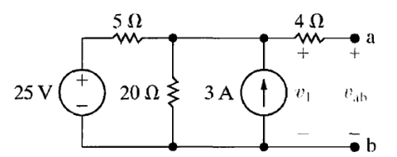 | L3 | CO4 | [8M]
 | OR
14 | Verify the reciprocity theorem for the network shown in the figure  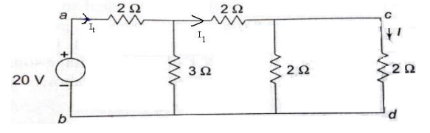 | L6 | CO4 | [8M]
15 | Obtain ABCD parameters for the network shown in Fig  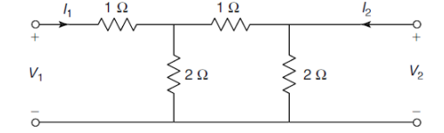 | L4 | CO5 | [8M]
 | OR
16 | Derive the condition of symmetry and Reciprocity for ABCD-parameters. | L5 | CO5 | [8M]
17 | A series RL circuit has R= 25 Ω and L = 5 Henry. A dc voltage of 100 V is applied to this circuit at t = 10 secs. Find : (a) The equations for the charging current , and voltage across R & L (b) The current in the circuit 0.5 secs after the voltage is applied. (c) The time at which the voltage drops across R and L are equal. | L3 | CO6 | [8M]
 | OR
18 | Derive expression for transient response of series R-C circuit driven by DC excitation by using differential equation method? | L5 | CO6 | [8M]

-- 00 -- 00 –

